**Aim : Design the following**

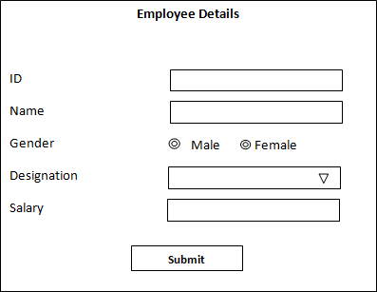

**Source code :**

<!DOCTYPE html>

<html>

<head>

<style>

input[type = text] {

width: 45%;

padding: 3px 15px;

box-sizing: border-box;

margin-left:195px

}

select {

width: 45%;

padding: 3px 15px;

box-sizing: border-box;

margin-left:155px

}

input[type = radio] {

margin-left:137px

}

input[type = submit] {

width: 30%;

padding: 5px 15px;

}

</style>

</head>

<body>

<center><div style="width:450px;height:350px;border:1px solid black; ">

<h3><center>Employee Details</center></h3><br>

<form action="" method="post">

ID <input type="text" id="id" name="id"><br><br>

Name <input type="text" id="name" name="name"><br><br>

Gender <input type="radio" name="gen" value="male">Male

<input type="radio" name="gen" value="female">Female<br><br>

Destination <select id="des" name="des">

<option value=""></option>

<option value="abs">Tvpm</option>

<option value="cdg">Trssr</option>

<option value="lrn">Plkkd</option>

<option value="wvt">Kllm</option>

</select>

<br><br>

Salary <input type="text" id="sal" name="sal"><br><br>

<input type="submit" value="Submit"><br><br>

</form></div></center>

</body>

</html>